**Script for YouTube Video: Interface Segregation Principle (ISP)**

**[Opening Sequence]**

[Show title screen with dynamic background music and the title: "Understanding the Interface Segregation Principle in C#: Writing Focused and Flexible Code"]

**[Introduction]**

**Host**: "Hey everyone! Welcome back to [Your Channel Name]. Today, we’re diving into the fourth principle of SOLID—the **Interface Segregation Principle**, or ISP."

**Host**: "This principle teaches us to create smaller, focused interfaces that are tailored to the specific needs of a class rather than bloated ones that force classes to implement unnecessary methods."

**Host**: "We’ll cover everything from real-world analogies to code examples using an HR Management System project. Make sure to like, subscribe, and hit the bell icon to keep up with our SOLID series!"

**[Part 1: What is the Interface Segregation Principle?]**

**Host**: "The Interface Segregation Principle is all about creating interfaces that are specific to what a class actually needs. It states: ‘Clients should not be forced to depend on interfaces they do not use.’"

[Display this text on-screen.]

**Host**: "In simpler terms, a class should not be burdened with methods it doesn’t need. This helps us write focused, flexible, and reusable code."

**[Part 2: Real-Life Analogy]**

[Show visuals of an HR system with different roles: Admin, Recruiter, and Employee.]

**Host**: "Imagine a large HR Management System. An Admin can manage user accounts, a Recruiter can shortlist candidates, and an Employee can view their payslips. Would it make sense for the Employee to implement methods for adding new users or shortlisting candidates? Definitely not!"

**Host**: "This is where the Interface Segregation Principle comes into play. Instead of forcing a single interface on all roles, we create separate, role-specific interfaces."

**[Part 3: Example of Violating ISP]**

[Switch to Visual Studio or your preferred IDE.]

**Host**: "Let’s look at an example where we violate ISP in an HR Management System."

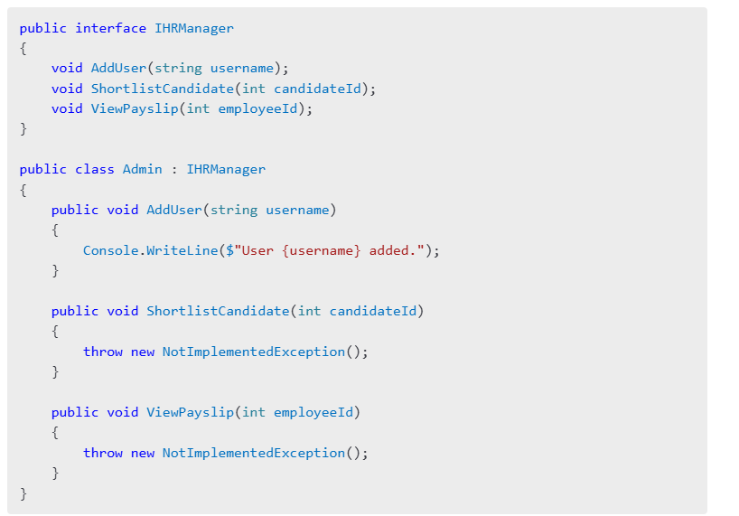

**Host**: "Here, the IHRManager interface is forcing all classes, like Admin, to implement methods they don’t need, such as ShortlistCandidate and ViewPayslip. This violates the Interface Segregation Principle."

**[Part 4: Refactoring to Follow ISP]**

**Host**: "To fix this, we split the IHRManager interface into smaller, more focused interfaces."

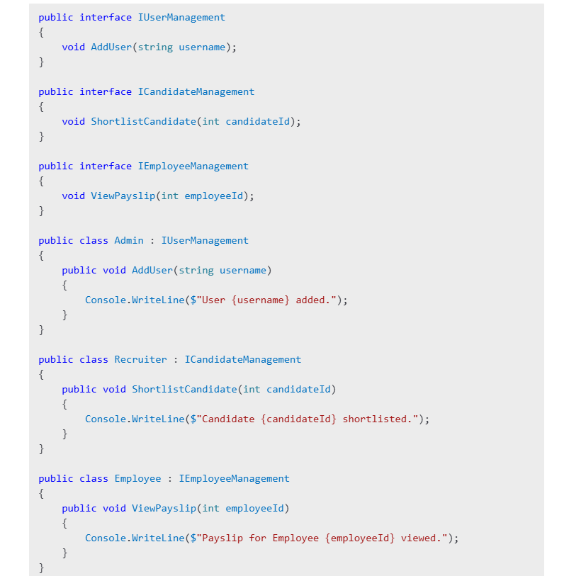

**Host**: "Now, each role only implements the methods it needs. This adheres to ISP and keeps our code cleaner and more maintainable."

**[Part 5: Advantages and Disadvantages of ISP]**

**Host**: "Let’s quickly discuss the pros and cons of following the Interface Segregation Principle."

**Advantages**:

* "Promotes focused and reusable interfaces."
* "Prevents unnecessary dependencies between classes."
* "Improves code readability and maintenance."

**Disadvantages**:

* "Can lead to too many small interfaces, which may be hard to manage."
* "Requires careful planning to balance interface granularity."

**[Part 6: Best Practices for Implementing ISP]**

**Host**: "Here are some best practices for applying ISP in your projects."

1. "Analyze the specific needs of each class before designing interfaces."
2. "Group related methods logically into smaller interfaces."
3. "Use tools like dependency inversion to further decouple interfaces."

**[Part 7: Closing and Call-to-Action]**

**Host**: "To summarize, the Interface Segregation Principle ensures that your classes are not burdened with methods they don’t need, making your code more focused and adaptable."

**Host**: "Have you ever struggled with bloated interfaces in your projects? Share your thoughts in the comments!"

**Host**: "If you enjoyed this video, give it a thumbs up and subscribe to [Your Channel Name] for more insights on SOLID principles. Stay tuned for the final principle—the **Dependency Inversion Principle**!"

[End with upbeat music and your channel logo.]

**[On-Screen Text Suggestions]**

1. "Key Takeaway: Keep interfaces small and focused."
2. "Best Practice: Analyze class needs before designing interfaces."
3. "Up Next: Dependency Inversion Principle."

**Suggested B-Roll and Visuals**

1. **Role-Based System**: Show a diagram of an HR system with Admin, Recruiter, and Employee roles.
2. **Animations**: Demonstrate the process of splitting one large interface into smaller interfaces.
3. **Text Popups**: Highlight key points during the code walkthrough.

Let me know if this script needs further refinements or if you'd like me to proceed with the Dependency Inversion Principle (DIP).